Assignment2 report

Haijin He

Part1:

PART 1: Given the dataset in Assignment 1, train three classifiers of your choice on the data to achieve the highest possible cross-validated accuracy. You may use any library you want. You will turn in a report describing your activity and the results you obtain.

Tool for part1: Orange

Classifiers: decision tree, Naïve Bayes, logistic regression, Random Forest, kNN

The data format is first converted to csv using a Python 3 script converter.py

Data then loaded into Orange and various models are used to evaluation accuracy.

A data Sampler widget is added for fast computation, and for some reason if input data is large decision tree widget will give an error. Data Sampler is set to random sample 30% of input data.

Orange graph:

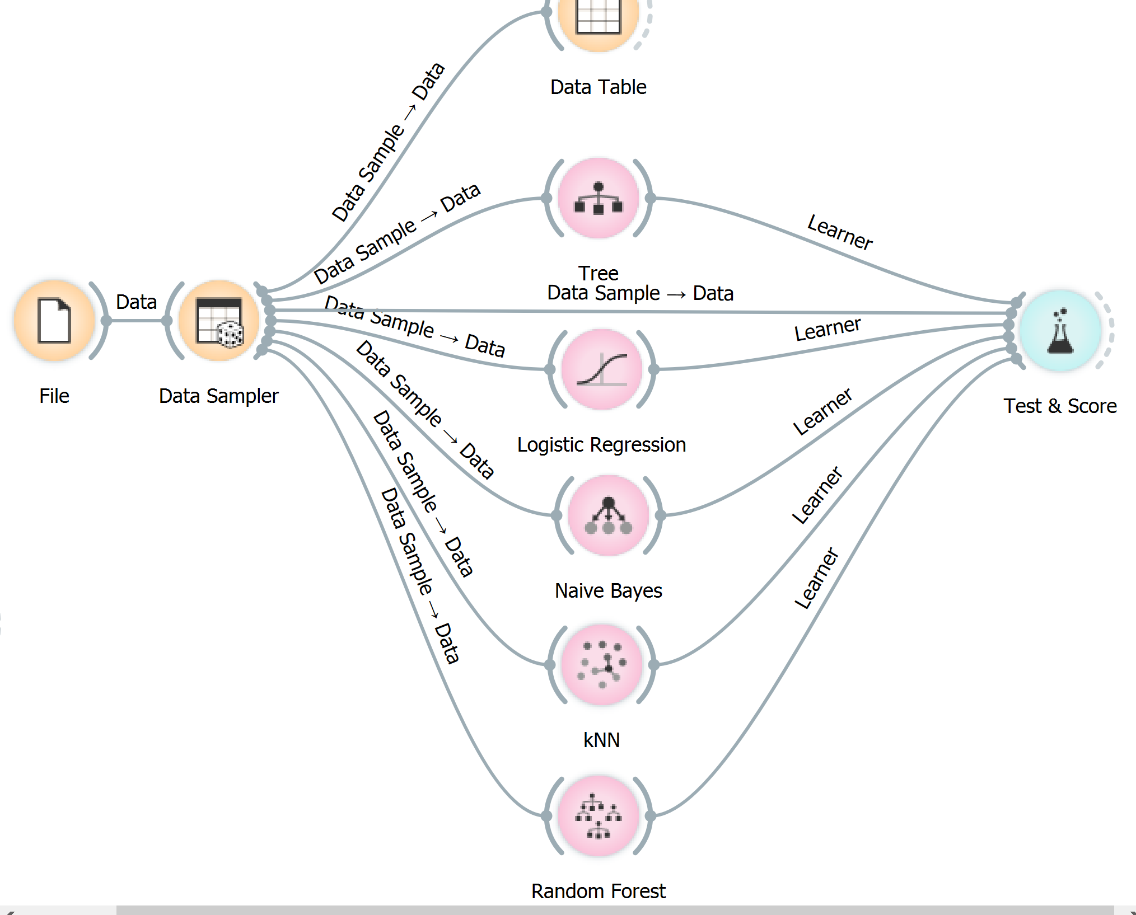

Result:

The best result is from Random Forest, which have a F1 of 0.999

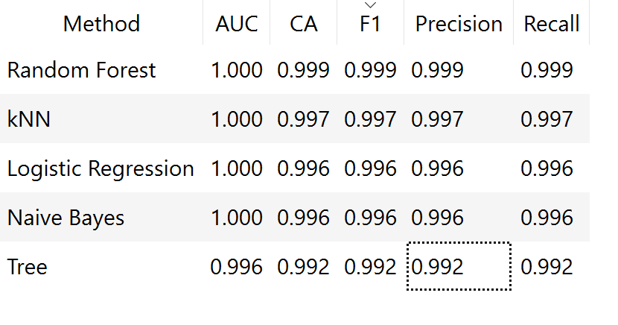

Part2:

PART 2: Program, in your preferred language, a hierarchical clustering algorithm to cluster the dataset in Assignment 1. You will measure goodness of your clustering using Rand Index. You may tune the cut-off parameter to obtain high accuracy. You may use the knowledge that number of clusters is four.

Programming language: Python 3

Source file: hierarchical.py

Hierarchical clustering algorithm: Agglomerative

Distance measure: Euclidean

Distance between clusters: average distance.

Due to the implementation efficiency, only 400 samples from assignment 1 is fed to the algorithm and Rand index evaluated.

A plot is generated to show the relationship of number of cluster in the result vs Rand Index.

We can see cluster number 4 is best, with a Rand Index of 0.98

It is interesting that cluster number above 4 only slightly reduced Rand Index. A closer look at the divided clusters showed they largely retains the 4 cluster structure, with other clusters having only one or a few data points. So the observation may be specific to the input data.

